PHS Human Subjects and Clinical Trials Form Information Guide

Q1. Does any of the proposed research in the application involve human specimens and/or data? (Answered within the Grants.gov S2S Questionnaire in the Proposal Development (PD) document.)
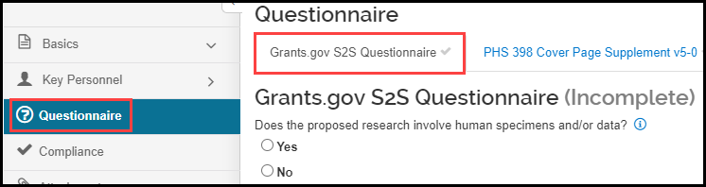
Q2. Are human subjects involved? (Answered by adding a Compliance entry with Human Subjects as the Type.)
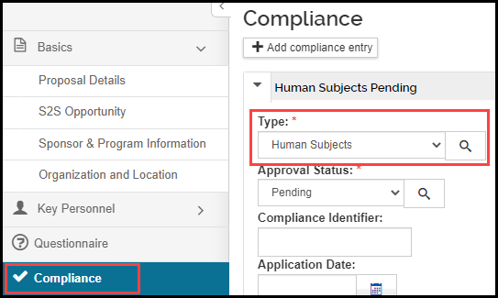
If there’s uncertainty whether the project involves human subjects research, NIH has developed a decision tool to help make this determination.

If the answers to both questions are ‘No’, this form is complete.
If the answer to Q1 is ‘Yes’ and the answer to Q2 is ‘No’, an attachment explaining why the human specimens and/or data is not considered human subjects research, is required.

To add this attachment:

- Go to the Attachments option of the PD:
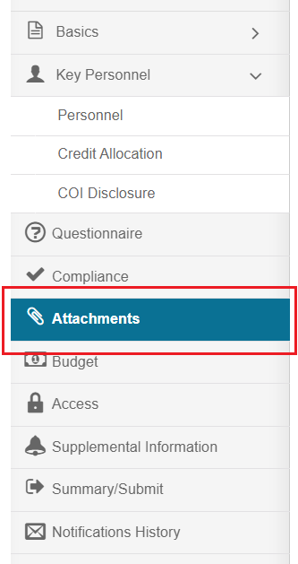
- On the Proposal tab, click ‘+ Add’ button:
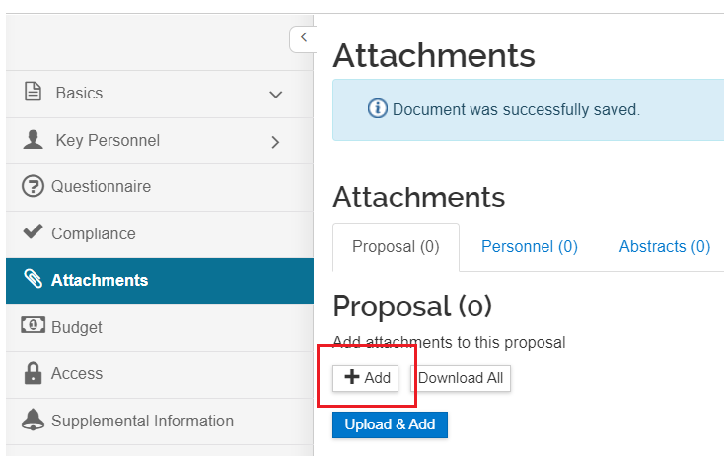

- Select the Attachment Type ‘PHS_HumanSubjectsAndCT_InvolveHumanSpecExp’ from the dropdown, select a Status (Complete or Incomplete), and click Choose File:
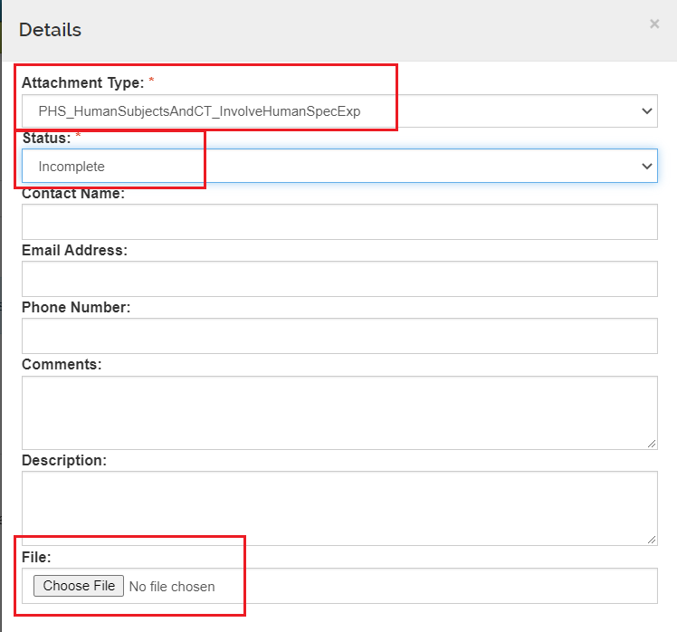
- Once the file is added, click ‘Save’.
NOTE: If you need to attach a document in the Other Requested Information field, you would attach it following the same process as above, except the Attachment Type would be ‘PHS_HumanSubjectsAndCT_OtherRequestedInfo’.

If the answers to both questions are ‘Yes’, at least one Delayed Onset explanation or Study Record is required.²

Delayed Onset Studies:
- Go to the Compliance option of the PD and click ‘+Add compliance entry’:
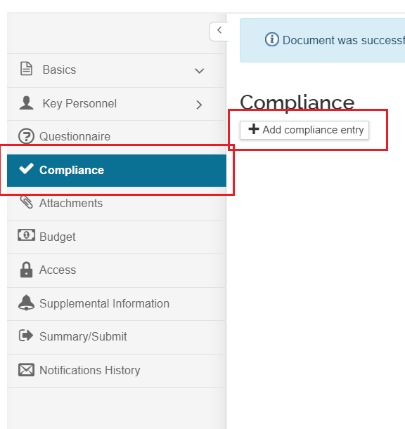

- Add a compliance entry for Human Subjects with an Approval Status of Pending (unless IRB approval has been obtained for this project)
- Check the Delayed Onset box
- If this is a clinical trial, check the Clinical Trial box
- Add a Study Title
- Add a Human Study Attachment with the justification for why this study is delayed onset
- Click ‘Add Entry’
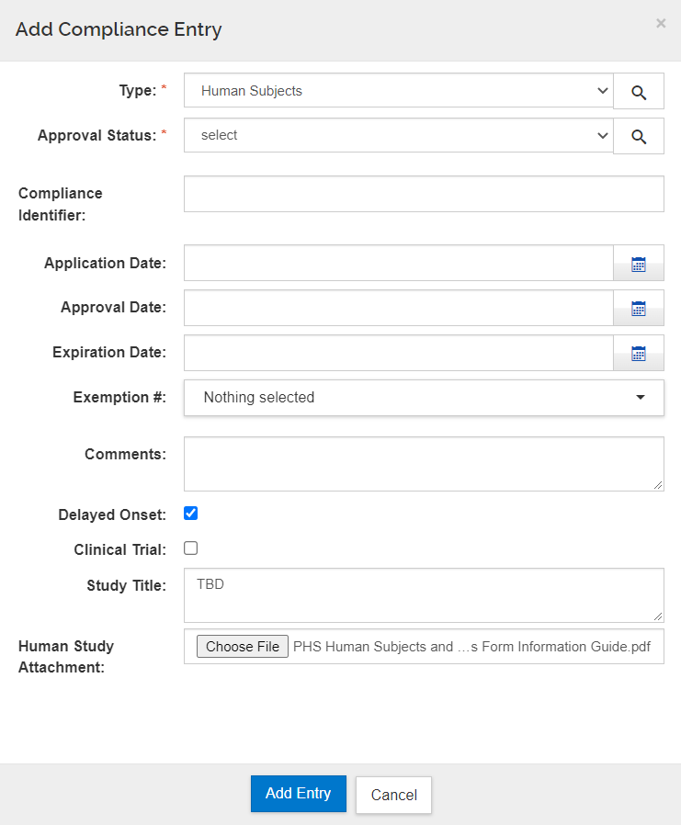

Non-exempt and Exempt Human Subject studies:
- From the Basics option, select the S2S Opportunity sub option, Forms tab. Click on the PHSHumanSubjectsandClinicalTrialsInfo form:
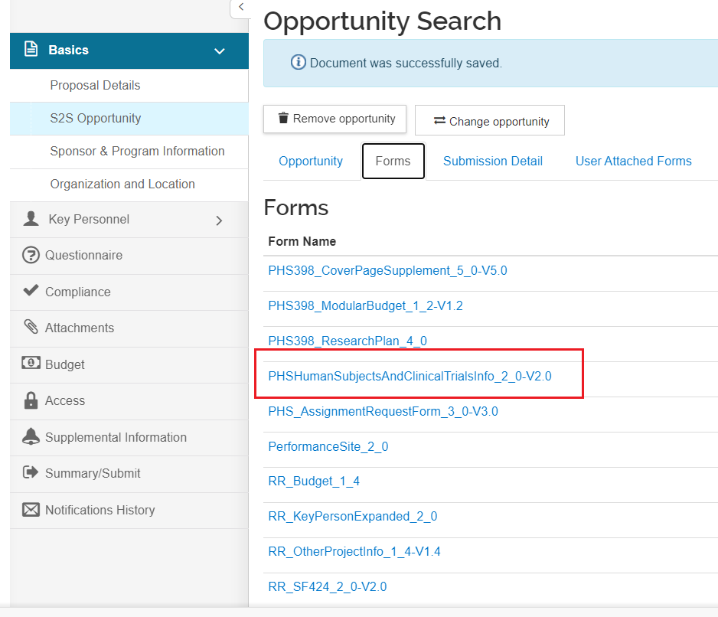
- Answer ‘Yes’ to the question, “Are Human Subjects Involved?”, then extract the Study Record from the downloaded form; complete and save the Study Record.
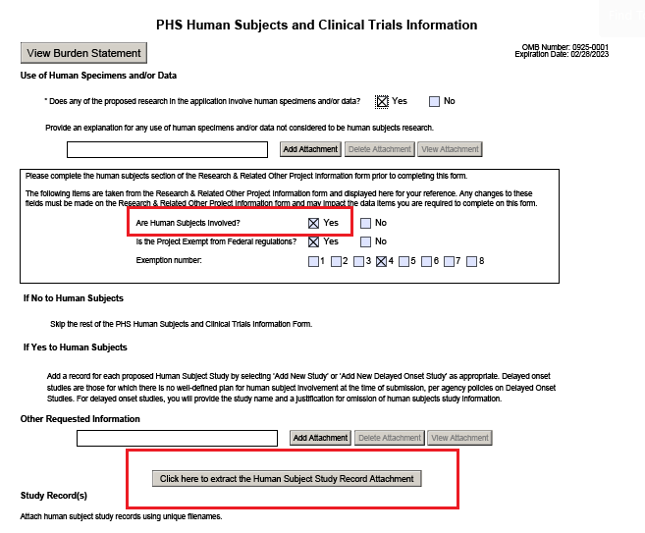
- Go to the Compliance option of the PD and click ‘+Add compliance entry’:

- Add a compliance entry for Human Subjects
- For the Approval Status:
  - Non-exempt – select Pending
  - Exempt – select Exempt
- If Exempt, select an Exemption # from the dropdown list
- If this is a clinical trial, check the Clinical Trial box
- Attach the completed Study Record
- Click ‘Add Entry’

Screenshot for Exempt:
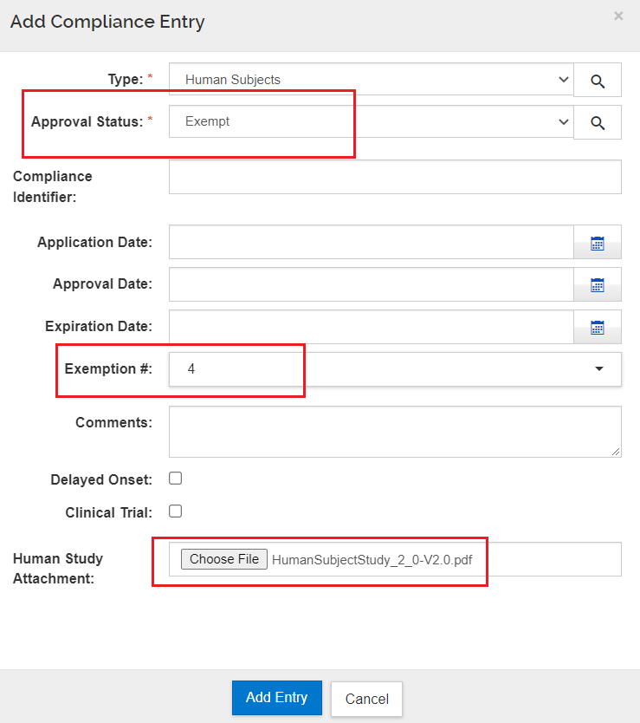
Screenshot for Non-exempt:
